**Introduction to Combinational Circuit Simulation Lab: 2**

***Half Adder***

***Student : Chandani Lapasia***

***User id : fpga0522-chan50***

**Code snippet for Half adder DATA flow modelling.**

**Design:**

module half_adder(sum,carry,in1,in2);

input in1, in2;

output sum, carry;

assign sum=(~in1 && in2) || (in1 && ~in2);

assign carry=(in1 && in2);

endmodule

**Testbench:**

module test_tb();

reg in1,in2;

wire sum, carry;

half_adder u0 (sum,carry,in1,in2);

initial begin

in1=0; in2=0;

#10 in1=0; in2=1;

#10 in1=1; in2=0;

#10 in1=1; in2=1;

end

initial begin

$monitor($time, "in1=%d in2=%d carry=%d sum=%d", in1, in2,carry, sum);

end

endmodule

**Output waveform:**

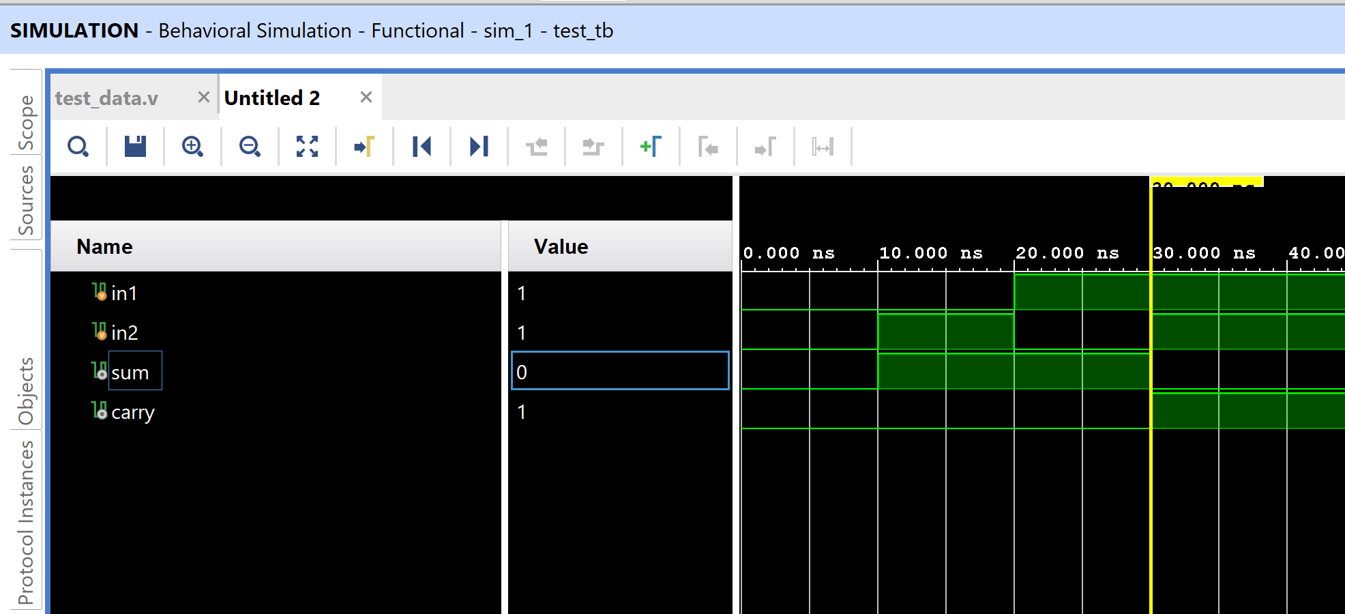

**Output console :**

0 in1=0 in2=0 carry=0 sum=0

10 in1=0 in2=1 carry=0 sum=1

20 in1=1 in2=0 carry=0 sum=1

30 in1=1 in2=1 carry=1 sum=0

**Code snippet for Half adder BEHAVORAL flow modelling.**

**Design code :**

module half_adder_beh(carry,sum,in1,in2);

input in1, in2;

output sum, carry;

reg sum,carry;

always @(in1 or in2)

begin

{carry,sum}= in1+in2;

end

endmodule

**Testbench code :**

module tb_half_adder();

reg in1, in2;

wire carry, sum;

half_adder_beh u0(carry,sum,in1,in2);

initial begin

in1=0; in2=0;

#10 in1=0; in2=1;

#10 in1=1; in2=0;

#10 in1=1; in2=1;

end

initial begin

$monitor($time, "in1=%d in2=%d carry=%d sum=%d", in1, in2,carry, sum);

end

endmodule

**Output waveform :**

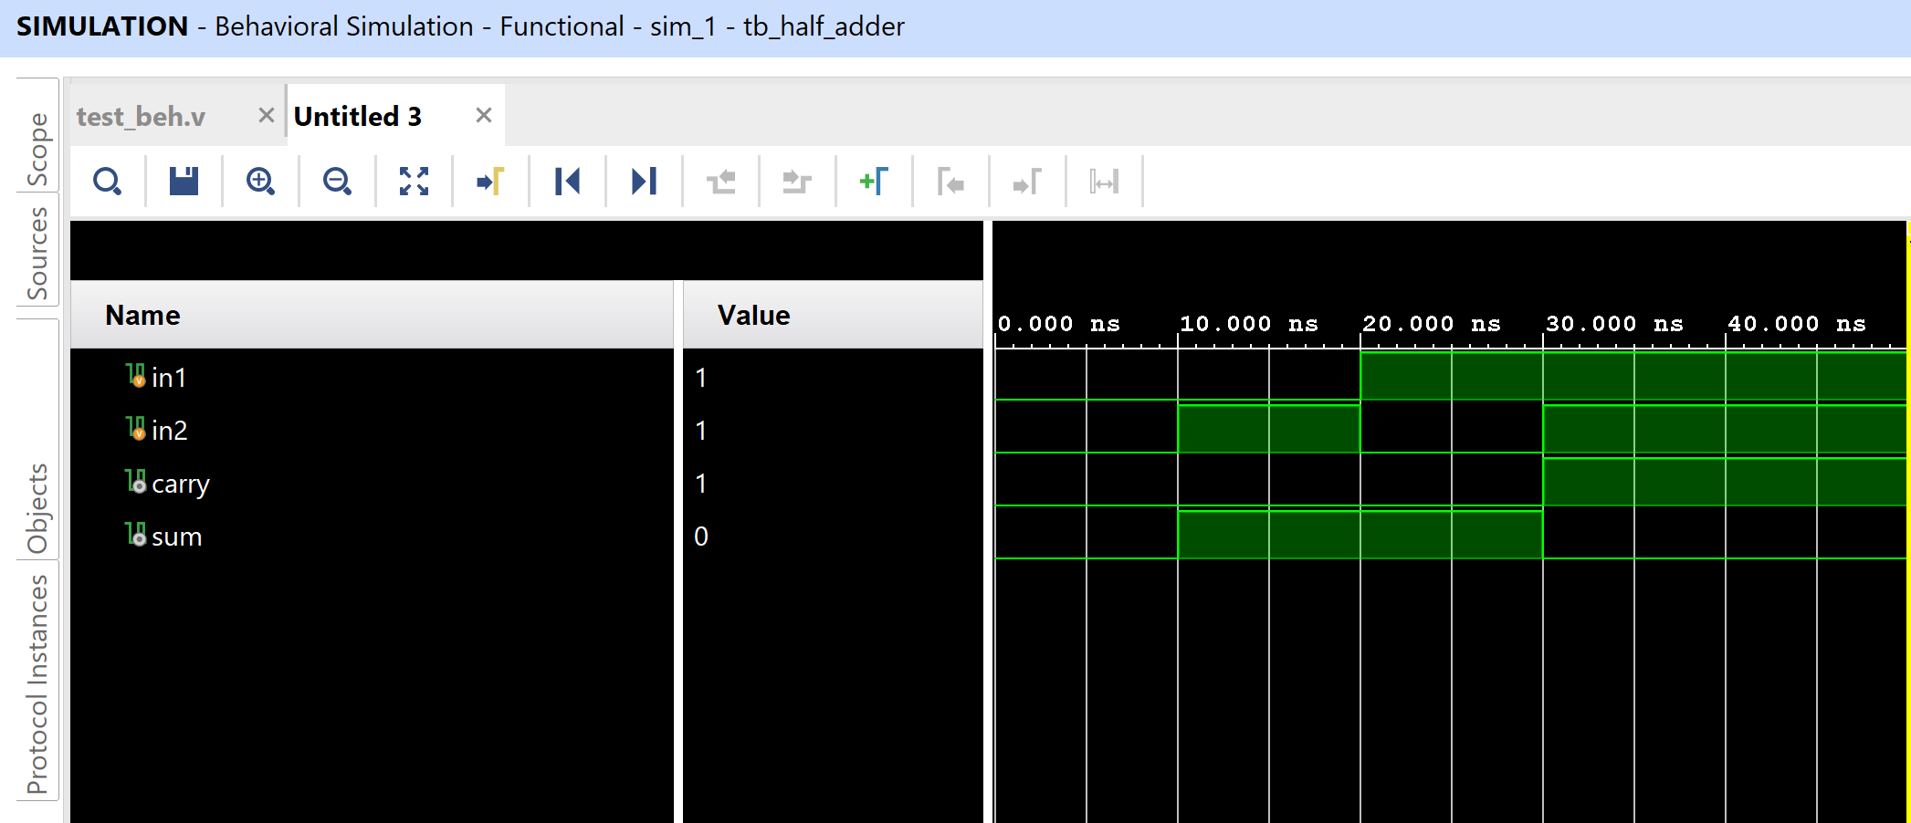

**Output console :**

0 in1=0 in2=0 carry=0 sum=0

10 in1=0 in2=1 carry=0 sum=1

20 in1=1 in2=0 carry=0 sum=1

30 in1=1 in2=1 carry=1 sum=0

**Code snippet for Half adder STRUCTURAL flow modelling.**

**Design code :**

module test_half_adder_str(sum,carry,in1,in2);

input in1, in2;

output sum,carry;

wire temp1, temp2, temp3, temp4;

and(carry, in1, in2);

not(temp1, in1);

not(temp2,in2);

and(temp3,temp1,in2);

and(temp4,in1,temp2);

or(sum,temp3,temp4);

endmodule

**Testbench code :**

module tb_half_adder();

reg in1,in2;

wire sum,carry;

test_half_adder_str u0(sum,carry,in1,in2);

initial begin

in1=0; in2=0;

#10 in1=0; in2=1;

#10 in1=1; in2=0;

#10 in1=1; in2=1;

end

initial begin

$monitor($time, "in1=%d in2=%d carry=%d sum=%d", in1, in2,carry, sum);

end

endmodule

**Output waveform :**

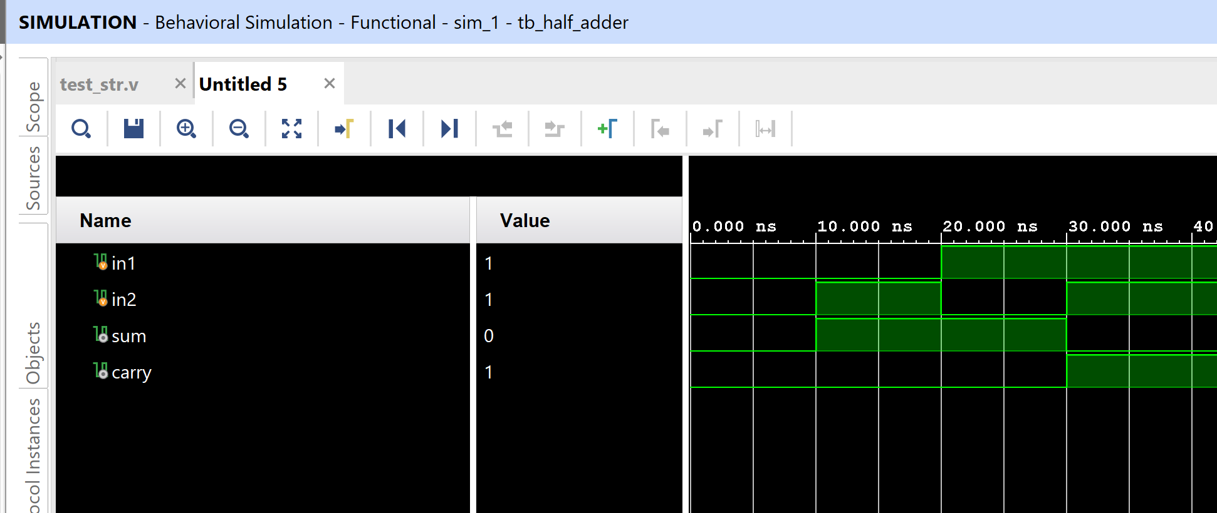

**Output console :**

0 in1=0 in2=0 carry=0 sum=0

10 in1=0 in2=1 carry=0 sum=1

20 in1=1 in2=0 carry=0 sum=1

30 in1=1 in2=1 carry=1 sum=0

**Question and Answers for Lab2 are answered in second PDF along with Full Adder design.**

**=============================== END=========================================**